8 How to Copy and Paste Keyframes in DaVinci Resolve on Edit Page
~ Part 1~

Watch it, if you want to do a copy and paste of key frames and do all the work in the Edit panel, you cannot use Text. Text is one of those things that will force you into the Fusion Panel.
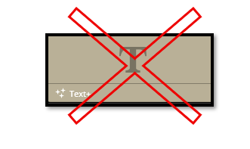

Start bringing in your images to the Medial Pool, inside of DaVinci. We will use a background image on the bottom track and a text layer on the track over it.
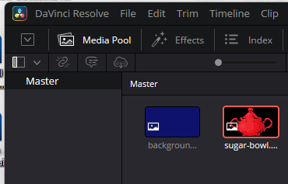

Then drag your two layers down on the timeline
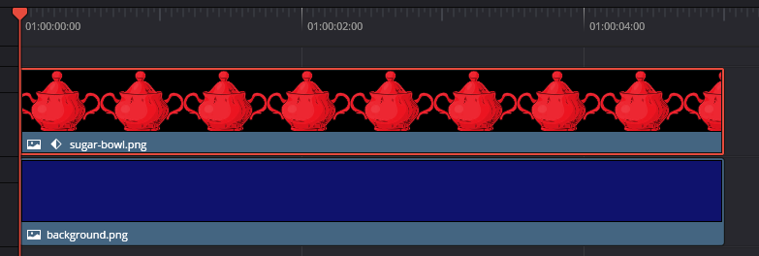

Now select the (in my case) the sugar bowl clip on your timeline. Start on Frame 1 to set your starting position. Always set a starting key frame on frame one, so DaVinci understands where it is starting from. And Davini will just start where you set your next key frame as a starting position, and you probably wanted some movement between these two frames, so that makes no sense.
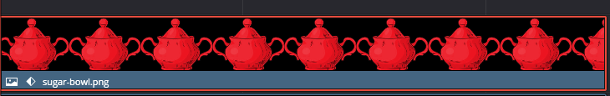
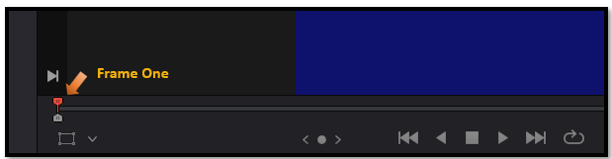
We are starting with the sugar bowl off the left side of the screen and then animate it in. It is going to travel across the screen and leave the screen on the right side.
Hit your diamond next to the parameter for X and Y. To start animating those positions. Notice the diamond is red after hitting it. This means the keyframe has been locked in and moving its position when we move the playhead to another position and setting a new keyframe with the new position, probably center screen, at midway through the video.
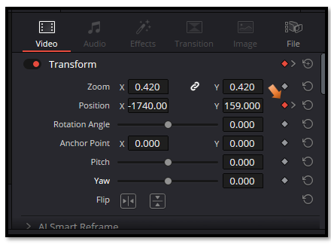
Remember to set your last key frame. And now we can open the Keyframe panel on the Edit page.
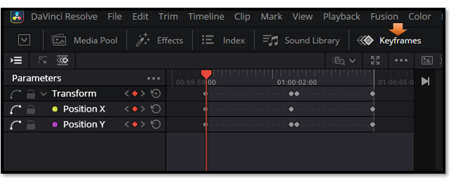
To see the same thing that I have above, turn on these icons. The first shows the Parameter names, and the second icon lets you see the diamonds representing the keyframes.
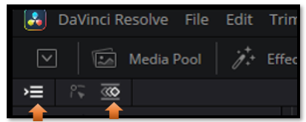
Even though selecting that second icon will allow you to quickly select keyframes. We are going to first add some easing, and to do that it is actually best to select the second icon.
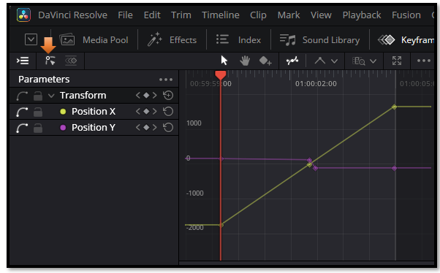
Draw-select a box around your keyframes that you see above.
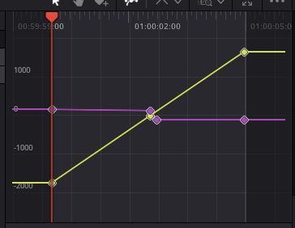
Now right click and then hover over to choose the easing that you want.

Here we choose Ease In and Out
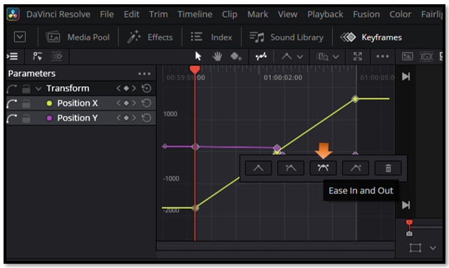
Your keyframes will change.
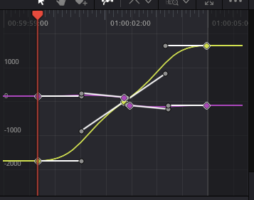

Now to Copy and paste your keyframes
Bring in a new image to use that we can paste the keyframes into. And place the new image on the timeline next to the first movie clip with the sugar bowl in it.
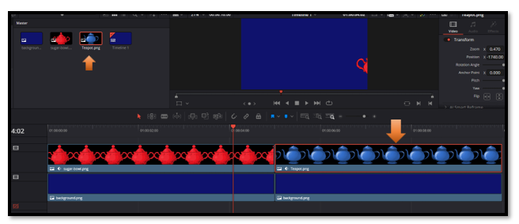
Now click on the red sugar bowl clip on the timeline. Go back to the keyframes panel. Select all the keyframes in the panel
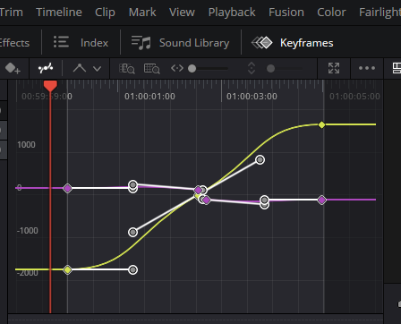
Go to the very top Menu and choose Edit- Copy
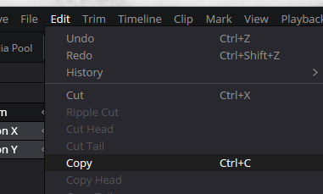
Now click on the blue teapot clip on the timeline and choose Edit Paste. And Wa-La. Now your teapot is acting in the exact same way as the sugar bowl did.
